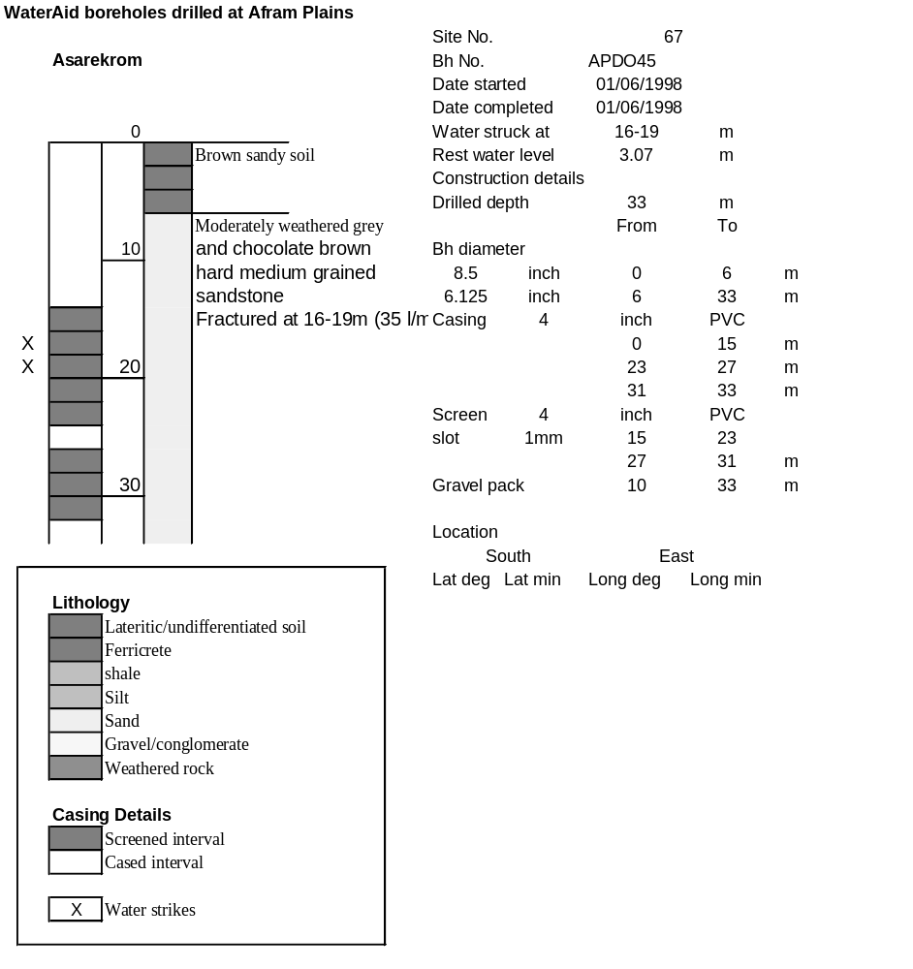

Ghana | Test pumping
Borehole No. |  | APDO45
Hole No |  | 67 | (17)
Village |  | Asarekrom
Date |  | 21/11/1998
Point above GL |  | 0.65 | m
Pump depth |  | 25 | m
SWL |  | 3.72 | m
Start Time |  | 07:40
Drawdown test |  |  |  |  | Recovery Test
time | pwl (m) | Q l/min | dd | sc(q/s) | Time | wl (m) | t/t' | resdd
0.00 | 3.72 | 30.00 | 0.00 |  | 0.00 | 9.20 |  | 5.48
1.00 | 5.23 | 30.00 | 1.51 | 19.87 | 1.00 | 7.52 | 241.00 | 3.80
2.00 | 5.64 | 30.00 | 1.92 | 15.63 | 2.00 | 6.72 | 121.00 | 3.00
3.00 | 6.00 | 30.00 | 2.28 | 13.16 | 3.00 | 6.30 | 81.00 | 2.58
4.00 | 6.35 | 30.00 | 2.63 | 11.41 | 4.00 | 6.07 | 61.00 | 2.35
5.00 | 6.57 | 30.00 | 2.85 | 10.53 | 5.00 | 5.93 | 49.00 | 2.21
6.00 | 6.71 | 30.00 | 2.99 | 10.03 | 6.00 | 5.83 | 41.00 | 2.11
7.00 | 6.83 | 30.00 | 3.11 | 9.65 | 7.00 | 5.74 | 35.29 | 2.02
8.00 | 6.94 | 30.00 | 3.22 | 9.32 | 8.00 | 5.67 | 31.00 | 1.95
9.00 | 7.03 | 30.00 | 3.31 | 9.06 | 9.00 | 5.61 | 27.67 | 1.89
10.00 | 7.11 | 30.00 | 3.39 | 8.85 | 10.00 | 5.57 | 25.00 | 1.85
12.00 | 7.23 | 30.00 | 3.51 | 8.55 | 12.00 | 5.48 | 21.00 | 1.76
14.00 | 7.31 | 30.00 | 3.59 | 8.36 | 14.00 | 5.41 | 18.14 | 1.69
16.00 | 7.38 | 30.00 | 3.66 | 8.20 | 16.00 | 5.34 | 16.00 | 1.62
18.00 | 7.44 | 30.00 | 3.72 | 8.06 | 18.00 | 5.29 | 14.33 | 1.57
20.00 | 7.49 | 30.00 | 3.77 | 7.96 | 20.00 | 5.24 | 13.00 | 1.52
25.00 | 7.60 | 30.00 | 3.88 | 7.73 | 25.00 | 5.14 | 10.60 | 1.42
30.00 | 7.68 | 30.00 | 3.96 | 7.58 | 30.00 | 5.06 | 9.00 | 1.34
35.00 | 7.75 | 30.00 | 4.03 | 7.44 | 35.00 | 5.00 | 7.86 | 1.28
40.00 | 7.84 | 30.00 | 4.12 | 7.28 | 40.00 | 4.93 | 7.00 | 1.21
45.00 | 7.90 | 30.00 | 4.18 | 7.18 | 45.00 | 4.88 | 6.33 | 1.16
50.00 | 7.97 | 30.00 | 4.25 | 7.06 | 50.00 | 4.85 | 5.80 | 1.13
55.00 | 8.04 | 30.00 | 4.32 | 6.94 | 55.00 | 4.80 | 5.36 | 1.08
60.00 | 8.08 | 29.00 | 4.36 | 6.65 | 60.00 | 4.76 | 5.00 | 1.04
70.00 | 8.31 | 30.00 | 4.59 | 6.54 | 70.00 | 4.70 | 4.43 | 0.98
80.00 | 8.40 | 30.00 | 4.68 | 6.41 | 80.00 | 4.65 | 4.00 | 0.93
90.00 | 8.49 | 30.00 | 4.77 | 6.29 | 90.00 | 4.61 | 3.67 | 0.89
100.00 | 8.55 | 30.00 | 4.83 | 6.21 | 100.00 | 4.57 | 3.40 | 0.85
110.00 | 8.62 | 30.00 | 4.90 | 6.12 | 110.00 | 4.55 | 3.18 | 0.83
120.00 | 8.68 | 30.00 | 4.96 | 6.05 | 120.00 | 4.53 | 3.00 | 0.81
130.00 | 8.73 | 30.00 | 5.01 | 5.99
140.00 | 8.78 | 30.00 | 5.06 | 5.93
150.00 | 8.83 | 30.00 | 5.11 | 5.87
160.00 | 8.88 | 30.00 | 5.16 | 5.81
170.00 | 8.93 | 30.00 | 5.21 | 5.76
180.00 | 8.97 | 30.00 | 5.25 | 5.71
190.00 | 9.02 | 30.00 | 5.30 | 5.66
200.00 | 9.06 | 30.00 | 5.34 | 5.62
210.00 | 9.10 | 30.00 | 5.38 | 5.58
220.00 | 9.13 | 30.00 | 5.41 | 5.55
230.00 | 9.17 | 30.00 | 5.45 | 5.50
240.00 | 9.20 | 30.00 | 5.48 | 5.47

